
UNIVERSITY OF
BUEA

FACULTY OF
ENGINEERING AND
TECHNOLOGY
(FET)

REPUBLIC OF
CAMEROON

PEACE-WORK-FATHERLAND

PROJECT TITTLE
TASK 4 REPORT
System Modelling and Design

Design and Implementation of a Crowdsensed Drive Test Mobile Application

for Coverage Prediction

COURSE TITLE: INTERNET PROGRAMMING AND MOBILE PROGRAMMING
COURSE CODE: CEF 440
COURSE INSTRUCTOR: Dr. Nkameni Valery

ACADEMIC YEAR 2025 - 2026

Project Group: Group 13
Submitted by:
1. Imele Azafa Jose de Kajos ………………………… FE23A068
2. Ayuk Amelia Agbor Orock ………..……………… FE23A020
3. Ngome Fernandez Manyaka ……….……………… FE23A111
4. Tadjeu Ngnintedem Aubry-Junex …….…………… FE23A148
5. Bessong Takang Tabot Willy …………………..…… FE23A025

Abstract
This report presents the system modelling and design phase of CrowdSenseNet, a crowdsensed drive test mobile application built to address the problem of inconsistent and unmapped mobile network coverage in Cameroon. The design follows directly from the requirements specified in Task 3, translating them into a comprehensive set of Unified Modelling Language (UML) diagrams that serve as a blueprint for implementation.

Six diagram types are covered: the Context Diagram, which defines the system boundary and its external actors; the Data Flow Diagram, which shows how information moves through the system; the Use Case Diagram, which maps user interactions to system functions; the Sequence Diagram, which models the time-ordered flow of events for the core data collection scenario; the Class Diagram, which describes the static structure of the system using the MVVM architectural pattern; and the Deployment Diagram, which shows how software components are distributed across physical nodes.

Every design decision in this report is grounded in the stakeholder evidence gathered in Task 2 and the requirements formalised in Task 3. The system is built around three core design priorities: privacy (full anonymisation of all user data), battery efficiency (adaptive sampling below 5% drain per hour), and data quality (GPS accuracy filtering and a minimum 5-second sampling interval).

Contents
Design and Implementation of a Crowdsensed Drive Test Mobile Application 0
for Coverage Prediction 0
Abstract 2
List of Figures 6
List of Tables 6
1.0 Introduction 7
1.1 Project Background 7
1.2 Purpose of This Document 7
1.3 Scope 7
1.4 Definitions and Abbreviations 7
2.0 Modelling Methodology 9
3.0 Context Diagram 10
3.1 What is a Context Diagram? 10
3.2 Why It Matters for CrowdSenseNet 10
3.3 Components of the Context Diagram 10
3.3.1 The System 10
3.3.2 External Entities and Data Flows 10
3.4 Steps Used to Create the Context Diagram 11
3.5 Context Diagram Illustration 12
3.6 Summary 12
4.0 Data Flow Diagram 13
4.1 What is a Data Flow Diagram? 13
4.2 Design Considerations 13
4.3 Level 0 DFD (Context Diagram Reference) 13
4.4 Level 1 DFD: Internal Processes 13
4.4.1 Process 1.0: User Consent and Onboarding 13
4.4.2 Process 2.0: Signal Data Collection 13
4.4.3 Process 3.0: Local Storage Management 14
4.4.4 Process 4.0: Data Upload and Synchronisation 14
4.4.5 Process 5.0: Backend Validation and Storage 14
4.4.6 Process 6.0: Coverage Map Generation 14
4.4.7 Process 7.0: ML Coverage Prediction (Future Phase) 14
4.5 Key Data Flows 14
5.0 Use Case Diagram 17
5.1 What is a Use Case Diagram? 17
5.2 System Boundary 17
5.3 Actors 17
5.3.1 Primary Actors 17
5.3.2 Secondary Actors 17
5.4 Use Cases 18
5.5 Relationships 19
5.5.1 Include Relationships 19
5.5.2 Extend Relationships 19
5.6 Use Case Diagram Illustration 20
6.0 Sequence Diagram 21
6.1 What is a Sequence Diagram? 21
6.2 Actors and Lifelines 21
6.3 Message Flow 21
6.3.1 Phase 1: App Launch and Consent 21
6.3.2 Phase 2: Data Collection Loop 22
6.3.3 Phase 3: Upload 22
6.3.4 Phase 4: Coverage Map Serving 22
6.4 Design Decisions 23
6.5 Sequence Diagram Illustration 24
7.0 Class Diagram 25
7.1 What is a Class Diagram? 25
7.2 Architectural Overview 25
7.3 Classes by Layer 26
7.3.1 Presentation Layer 26
7.3.2 ViewModel Layer 26
7.3.3 Domain / Service Layer 27
7.3.4 Repository Layer 28
7.3.5 Data Layer 28
7.3.6 Network Layer 29
7.3.7 Enumerations 30
7.4 Relationships 30
7.4.1 Relationship Types Used 30
7.4.2 Dependency Relationships (1 to 1) 30
7.4.3 Association Relationships 31
7.4.4 Composition and Aggregation Relationships 32
7.5 Class Diagram Illustration 33
8.0 Deployment Diagram 34
8.1 What is a Deployment Diagram? 34
8.2 Architecture Overview 34
8.3 Node Breakdown 34
8.3.1 Android Device 34
8.3.2 Android System Services 35
8.3.3 Backend Server 35
8.3.4 ML Analytics Server (Future Phase) 35
8.4 Inter-Node Communication Paths 36
8.5 Modelling Tool and Challenges 36
8.6 Deployment Diagram Illustration 37
9.0 Member Contributions 38
10.0 Conclusion 40

List of Figures
Figure 1: Steps to create a context diagram
Figure 2: Context Diagram for CrowdSenseNet
Figure 3: Level 1 Data Flow Diagram for CrowdSenseNet
Figure 4: Use Case Diagram for CrowdSenseNet
Figure 5: Sequence Diagram: Core Data Collection Scenario
Figure 6: Class Diagram for CrowdSenseNet (MVVM)
Figure 7: Deployment Diagram for CrowdSenseNet

List of Tables
Table 1: UML diagram types and their purpose in this project
Table 2: External entities and their data flows
Table 3: Key data flows in the Level 1 DFD
Table 4: Use cases and their descriptions
Table 5: Actor justification
Table 6: Sequence diagram design decisions
Table 7: CrowdSenseNet class summary by layer
Table 8: Dependency relationships
Table 9: Association relationships
Table 10: Composition and aggregation relationships
Table 11: Deployment nodes and their roles
Table 12: Inter-node communication paths
Table 13: Member contribution summary

1.0 Introduction

1.1 Project Background
Mobile network users in Cameroon face daily problems: weak signals, sudden call drops, slow internet speeds, and coverage gaps in both rural and urban areas. At the same time, the traditional way of measuring coverage, sending engineers out in a vehicle with specialised equipment (called drive testing), is expensive, slow, and only covers the roads the engineers travel on. It cannot capture indoor coverage, pedestrian areas, or the experience of ordinary people going about their day.

CrowdSenseNet addresses this problem by turning ordinary Android smartphones into passive signal measurement devices. Every user who installs the app automatically contributes real signal readings from their location, building a continuously updated, crowd-sourced coverage map. This approach is cheaper, broader, and more representative than traditional drive testing.

1.2 Purpose of This Document
This document presents the complete system modelling and design for CrowdSenseNet. It translates the requirements formalised in Task 3 into a set of UML diagrams that serve as the architectural blueprint for implementation. Each diagram addresses a different aspect of the system: its boundaries, its data flows, its user interactions, its runtime behaviour, its static structure, and its physical deployment.

1.3 Scope
The design covers the full CrowdSenseNet system as defined by the Task 3 SRS, including the Android mobile application, the Python FastAPI backend server, the PostgreSQL/PostGIS database, and the machine learning analytics layer (modelled but deferred to a future phase). iOS support is excluded from this phase. The geographic scope is limited to Cameroon.

1.4 Definitions and Abbreviations
Term / Abbreviation | Definition
RSRP | Reference Signal Received Power. Primary LTE signal strength metric. Coverage hole threshold: below -110 dBm
RSRQ | Reference Signal Received Quality. Measures signal quality relative to interference
SINR | Signal to Interference-plus-Noise Ratio. Indicates signal clarity
UML | Unified Modelling Language. Standardised notation for system design
MVVM | Model-View-ViewModel. Architectural pattern used in the Android app
DFD | Data Flow Diagram. Shows how data moves through a system
UUID | Universally Unique Identifier. Random anonymous token generated on first launch
SRS | Software Requirements Specification. Produced in Task 3
GPS | Global Positioning System. Used for location tagging of signal readings
API | Application Programming Interface. Used to access hardware and backend services
KPI | Key Performance Indicator. Signal metrics like RSRP used by network engineers
MVP | Minimum Viable Product. The core set of must-have features for the first release
ML | Machine Learning. Used for coverage hole prediction
GeoJSON | Open standard format for geographic data, preferred by network engineers

Table 1.1: Key definitions and abbreviations

2.0 Modelling Methodology
The modelling and design phase translates the requirements gathered in Task 2 and formalised in Task 3 into a structured visual blueprint. We used the Unified Modelling Language (UML), a standardised international framework for representing system architecture, behaviour, and structure.

The process was iterative. The team started with the highest-level view of the system (the context diagram) and progressively moved to more detailed representations (class and deployment diagrams). This top-down approach ensures that every detail in the lower-level diagrams can be traced back to the system boundary and stakeholder requirements established at the top.

Diagram | Type | Purpose in This Project
Context Diagram | Structural | Defines the system boundary and shows all external actors and their data flows with CrowdSenseNet
Data Flow Diagram | Structural | Shows how data moves through internal processes, data stores, and external entities
Use Case Diagram | Behavioural | Captures the functional interactions between actors and the system
Sequence Diagram | Behavioural | Models the time-ordered message flow for the core data collection scenario
Class Diagram | Structural | Defines the static object-oriented structure of the Android app following the MVVM pattern
Deployment Diagram | Structural | Maps software components onto physical execution environments across the three-tier architecture

Table 2.1: UML diagram types and their purpose in this project

Diagrams were created using draw.io and EdrawMax. All design decisions are grounded in evidence from Task 2 stakeholder data and are traceable to specific requirements in the Task 3 SRS.

3.0 Context Diagram
Prepared by: Tadjeu Ngnintedem Aubry-Junex

3.1 What is a Context Diagram?
A context diagram is the highest-level view of any system. It shows the entire system as a single process at the centre, surrounded by all the external entities that send data to it or receive data from it. The diagram does not show any internal processes or details; its only job is to make the system boundary clear.

In system modelling, the context diagram is always the starting point. It ensures that everyone involved, whether developers, engineers, regulators, or supervisors, agrees on what belongs inside the system and what sits outside it before any detailed design work begins.

3.2 Why It Matters for CrowdSenseNet
CrowdSenseNet involves four very different groups of people: ordinary smartphone users who contribute data, network engineers who consume the coverage maps, government regulators who enforce privacy rules, and academic supervisors who evaluate the project. Without a context diagram, it is easy for different people to have different ideas about what the system is supposed to do and who it talks to. The context diagram gives everyone a single shared picture before any detailed design begins.

It also makes sure that every requirement from the Task 3 SRS is linked to a real external actor, preventing scope creep and ensuring no stakeholder has been forgotten.

3.3 Components of the Context Diagram

3.3.1 The System
At the centre is the CrowdSenseNet System, which includes the Android mobile application and the backend server. The system collects signal data, stores it locally, uploads it to the backend, generates coverage maps, and provides reports.

3.3.2 External Entities and Data Flows
External Entity | Data Sent to System | Data Received from System
Users (Smartphone Owners) | Signal readings (RSRP, RSRQ, SINR, GPS), consent confirmation, on/off toggle commands | Coverage feedback display, survey prompts, upload status notifications
Network Engineers (MTN, Orange) | Coverage map requests, export requests | Processed coverage heatmaps, GeoJSON/CSV data exports
Regulators (Telecom Authorities) | Privacy guidelines and compliance requirements | Anonymisation compliance reports
Supervisors (Lecturers) | Validation feedback and academic review comments | Project documentation, methodology reports
Table 3.1: External entities and their data flows

3.4 Steps Used to Create the Context Diagram
- Define the system boundary: identify what belongs inside CrowdSenseNet (the mobile app and backend) and what stays outside.
- Identify all external actors: list every person or organisation that sends data to or receives data from the system.
- Determine inputs and outputs: for each actor, specify exactly what data flows in and what flows out.
- Draw the data flow arrows: show the direction of communication between the system and each actor.
- Validate with stakeholders: confirm the diagram is complete and accurate before proceeding to the DFD.

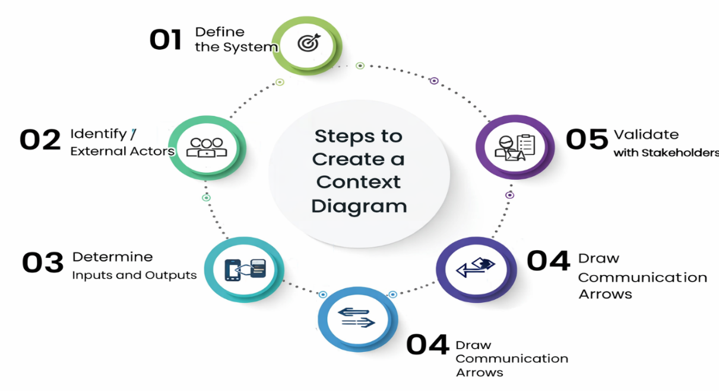
Figure 1: Steps to create a context diagram

3.5 Context Diagram Illustration
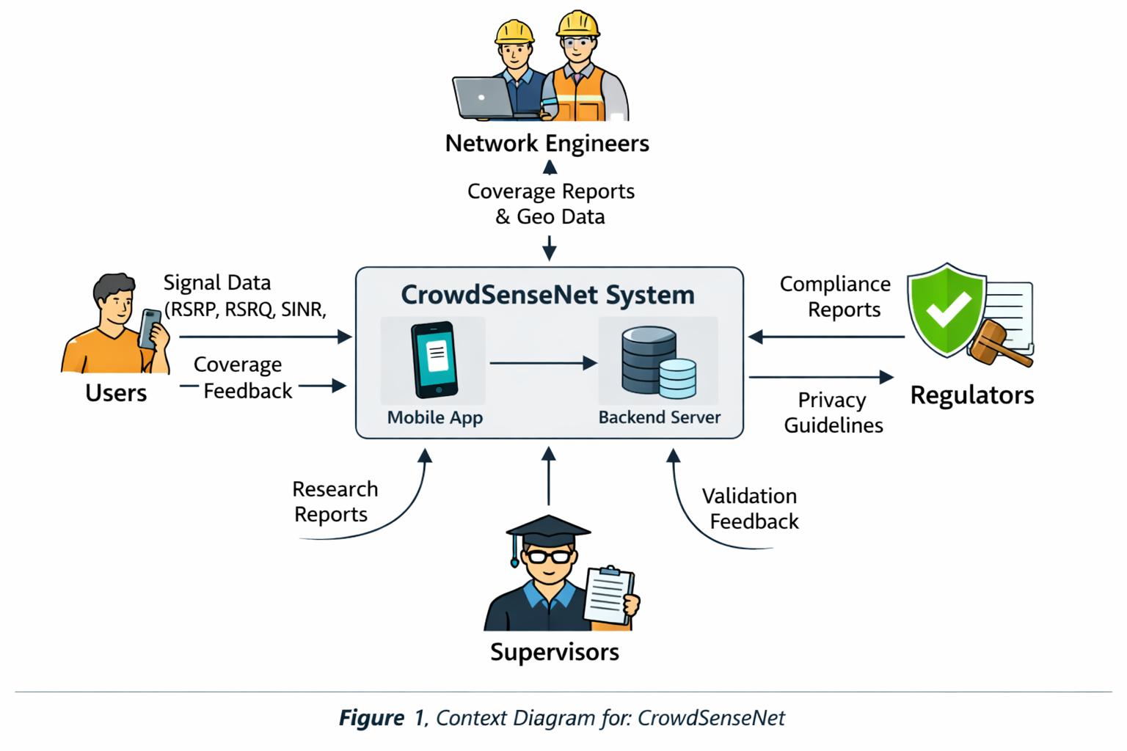
Figure 2: Context Diagram for CrowdSenseNet

3.6 Summary
The context diagram establishes the boundary of CrowdSenseNet and confirms that all four stakeholder groups from the Task 3 SRS are accounted for. Users feed raw signal data in and receive coverage feedback out. Engineers receive processed maps. Regulators receive compliance assurance. Supervisors receive documentation. This shared understanding is the foundation for every diagram that follows.

4.0 Data Flow Diagram
Prepared by: Imele Azafa Jose de Kajos

4.1 What is a Data Flow Diagram?
A Data Flow Diagram (DFD) shows how data moves through a system. While the context diagram (Level 0) shows the system as a single black box, the Level 1 DFD opens that box and shows the internal processes, the data stores, and how data flows between them and the external actors.

The DFD uses four elements: external entities (people or systems outside the boundary), processes (transformations that act on data), data stores (where data is held), and data flows (arrows showing the movement of data).

4.2 Design Considerations
- Clarity: every process, data store, and data flow is clearly labelled with a plain English name.
- Completeness: all data flows visible in the context diagram must appear at Level 1.
- No control flow: the DFD shows what data moves, not when or why. Decision logic belongs in sequence diagrams.
- Numbered processes: each process is numbered to make traceability easier.
- Consistent notation: standard DFD symbols are used throughout (rounded rectangles for processes, open-ended rectangles for data stores, squares for external entities).

4.3 Level 0 DFD (Context Diagram Reference)
The Level 0 DFD is the context diagram already presented in Section 3. It shows CrowdSenseNet as a single process receiving signal data from users and returning coverage information. The Level 1 DFD below decomposes that single process into its internal parts.

4.4 Level 1 DFD: Internal Processes

4.4.1 Process 1.0: User Consent and Onboarding
On first launch, the app presents a consent screen to the user. The user grants location and phone state permissions. The app generates a random anonymous UUID and stores it in local encrypted preferences. No personal information is collected at this stage. Output: a confirmed consent record and a UUID stored in the local preferences data store.

4.4.2 Process 2.0: Signal Data Collection
This is the core process of the system. When the user starts a session, the app calls the Android TelephonyManager API to read RSRP, RSRQ, SINR, and RSSI, and the FusedLocationProvider API to get GPS coordinates and accuracy. If the device is moving (speed above 5 km/h), readings are taken every 10 seconds. If the device is stationary for more than 30 seconds, collection pauses automatically. Any GPS reading with an accuracy worse than 15 metres is discarded. Valid readings are written immediately to the local Room database.

4.4.3 Process 3.0: Local Storage Management
All signal readings are stored in the local Room database before any upload is attempted. This ensures offline operation. The local database is capped at 50MB. When the cap is reached, the oldest readings that have already been uploaded are deleted automatically. Unsynced readings are never deleted.

4.4.4 Process 4.0: Data Upload and Synchronisation
The SyncManager monitors WiFi connectivity. When WiFi is available (default) or when the user has enabled mobile data upload, the app sends a batch of unsynced readings to the backend server over HTTPS/TLS 1.2. If the upload fails, the app retries automatically after 30 minutes. After a successful upload, the readings are marked as synced in the local database.

4.4.5 Process 5.0: Backend Validation and Storage
The backend FastAPI server receives the uploaded reading batch. It validates each reading: it checks that the GPS coordinates fall within the Cameroon bounding box, averages readings taken within a 10-metre radius of each other to remove duplicates, and verifies the authentication token. Valid readings are written to the PostgreSQL/PostGIS database.

4.4.6 Process 6.0: Coverage Map Generation
The backend generates a coverage heatmap by querying the PostGIS spatial database for readings within the requested area. Signal values are classified into good, average, poor, and coverage hole zones (RSRP below -110 dBm). The output is a GeoJSON feature collection that the app displays on the Map screen and that engineers can download as GeoJSON or CSV.

4.4.7 Process 7.0: ML Coverage Prediction (Future Phase)
Once sufficient data has accumulated (at least 50 readings per 1 km squared), the ML analytics server will classify unmeasured areas based on interpolated signal patterns. This process is modelled in the deployment diagram but is deferred to a future development phase as a Won't Have (now) requirement from the Task 3 MoSCoW prioritisation.

4.5 Key Data Flows
Data Flow | Source | Destination | Description
Consent confirmation | User | Process 1.0 | User grants permissions on first launch
UUID | Process 1.0 | Local Prefs store | Anonymous device token generated once and stored
TelephonyManager read | Process 2.0 | Android hardware | App requests RSRP, RSRQ, SINR, RSSI from cellular modem
Signal metrics | Android hardware | Process 2.0 | Raw KPI values returned by the TelephonyManager API
GPS fix | Android hardware | Process 2.0 | Latitude, longitude, and accuracy estimate from FusedLocationProvider
Filtered signal reading | Process 2.0 | Local DB | Validated reading (GPS accuracy passed) written to Room database
Unsynced readings | Local DB | Process 4.0 | Batch of readings not yet uploaded to the backend
Upload batch (HTTPS) | Process 4.0 | Backend server | Encrypted batch of anonymised readings sent over TLS 1.2
Upload acknowledgement | Backend server | Process 4.0 | Server confirms successful receipt; app marks readings as synced
Validated readings | Process 5.0 | PostgreSQL DB | Geographically valid, deduplicated readings stored server-side
Coverage map query | Engineer / App | Process 6.0 | Request for heatmap data for a specific area
GeoJSON heatmap | Process 6.0 | App / Engineer | Coverage map data returned for display or download
Session on/off toggle | User | Process 2.0 | User starts or stops data collection from the Home screen
Upload status notification | Process 4.0 | User | App notifies user when data has been uploaded or queued

Table 4.1: Key data flows in the Level 1 DFD

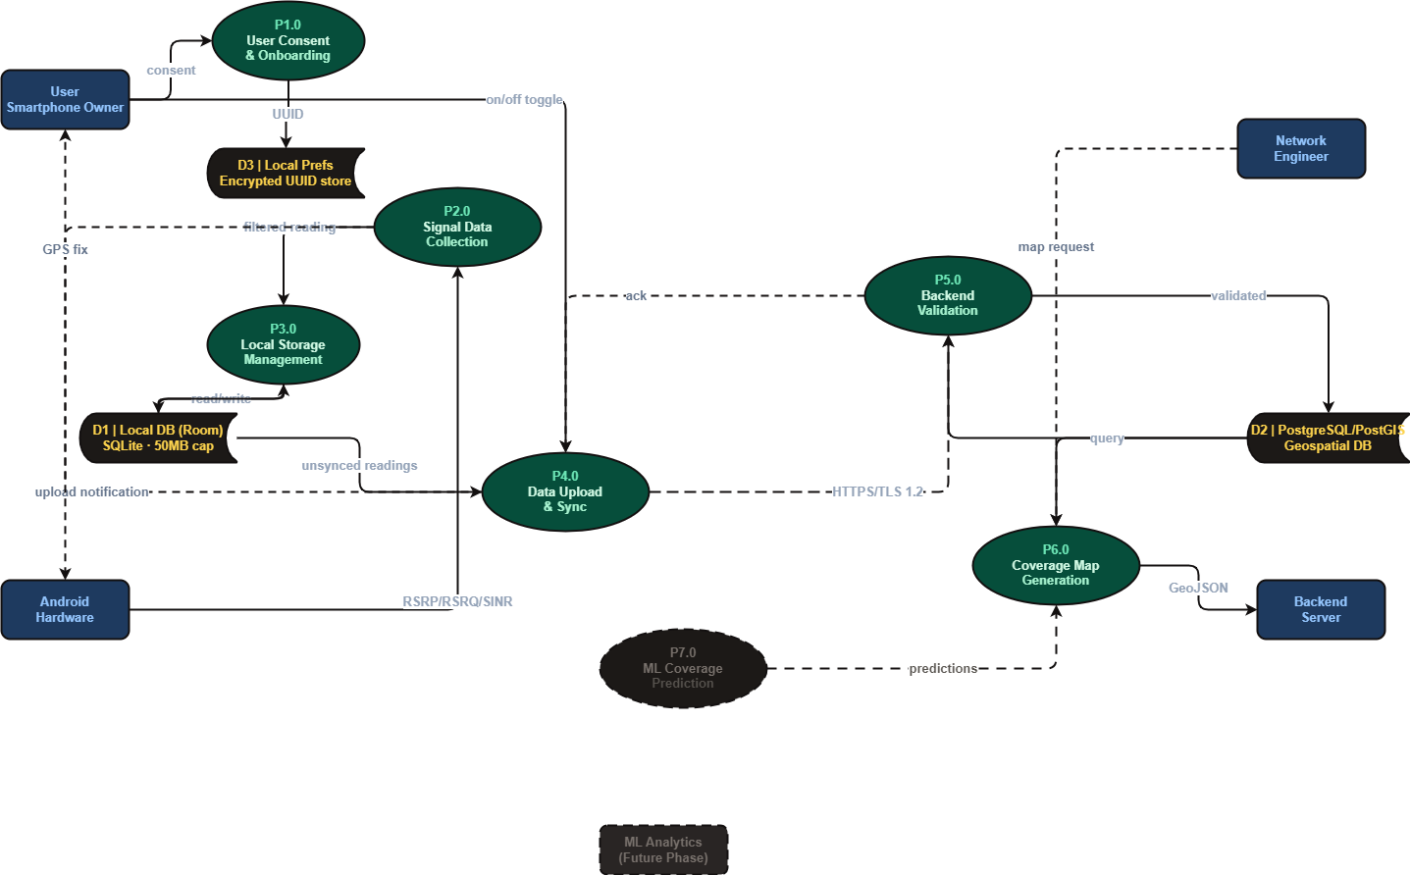
Figure 3: Level 1 Data Flow Diagram for CrowdSenseNet

5.0 Use Case Diagram
Prepared by: Imele Azafa Jose de Kajos

5.1 What is a Use Case Diagram?
A use case diagram is a behavioural UML diagram that shows what a system does from the perspective of its users. It identifies the actors (the people or systems that interact with the application) and the use cases (the actions or functions they perform). It does not show how those functions are implemented internally; that is the job of the sequence and class diagrams.

5.2 System Boundary
The system boundary defines what is inside CrowdSenseNet and what is outside. Everything inside the boundary is a function the app provides. Everything outside is an actor that uses those functions. The system boundary for this project encloses the CrowdSenseNet mobile application and backend.

5.3 Actors

5.3.1 Primary Actors
Actor | Role | Justification for Inclusion
User (Smartphone Owner) | Primary data contributor. Uses the app to contribute signal data passively. | The app cannot function without users contributing data. All core functional requirements (FR-01 to FR-12) are driven by user interaction.
Network Engineer (MTN / Orange) | Primary data consumer. Uses coverage maps and exported data for network planning. | Engineers were the primary source of technical requirements (KPIs, GPS threshold, sampling interval). They are the main professional beneficiaries of the system.
Android System Services | Non-human actor. Provides hardware access (TelephonyManager, FusedLocationProvider). | The app depends on these OS-level APIs for all signal and location data. They are an essential technical actor even though they are not human.

Table 5.1: Primary actors and their justification

5.3.2 Secondary Actors
- Regulators: provide privacy guidelines that shape how the system handles data. They do not interact with the app directly but constrain its design.
- Supervisors: review documentation and validate the academic methodology. They interact with project outputs rather than the live system.

5.4 Use Cases
Use Case | Actor(s) | Description
Start / Stop Data Collection | User | User taps a single button to begin or end a data collection session (FR-01)
View Live Signal Dashboard | User | User sees real-time RSRP, RSRQ, SINR, and GPS status on the Home screen
View Coverage Heatmap | User, Network Engineer | Both actors can view the colour-coded coverage map showing good, average, poor, and coverage hole zones
View Session History | User | User browses past sessions with date, duration, reading count, and upload status
Configure Settings | User | User adjusts collection mode (background/foreground), sampling interval, upload mode (WiFi only or mobile data), and language
Upload Data to Server | User (triggered), Android System Services (automated) | App automatically uploads buffered readings to the backend when connectivity conditions are met
Export Coverage Data | Network Engineer | Engineer downloads coverage data in GeoJSON or CSV format from the web interface (FR-12)
Grant Permissions | User | On first launch, user grants location and phone state permissions through the onboarding screen (FR-08)
Collect Signal Reading | Android System Services | TelephonyManager reads RSRP, RSRQ, SINR, and RSSI every 10 seconds while the device is moving (FR-04)
Provide GPS Fix | Android System Services | FusedLocationProvider returns latitude, longitude, and accuracy for each reading (FR-05)
Anonymise and Store Reading | User (implicit) | App strips all PII and writes the anonymised reading with a UUID token to the local database (FR-07, FR-08)
Sync Data on Retry | Android System Services | WorkManager retries failed uploads every 30 minutes automatically (FR-11)

Table 5.2: Use cases, actors, and descriptions

5.5 Relationships

5.5.1 Include Relationships
- Start Data Collection includes Collect Signal Reading (data collection always triggers a reading cycle)
- Collect Signal Reading includes Provide GPS Fix (every reading requires a GPS tag)
- Collect Signal Reading includes Anonymise and Store Reading (every reading is anonymised before storage)
- Upload Data to Server includes Sync Data on Retry (retry logic is always part of the upload process)

5.5.2 Extend Relationships
- View Coverage Heatmap may extend Export Coverage Data (engineers can optionally export what they are viewing)
- Configure Settings may extend Enable Mobile Data Upload (mobile data upload is an optional extension of the default WiFi-only setting)

5.6 Use Case Diagram Illustration
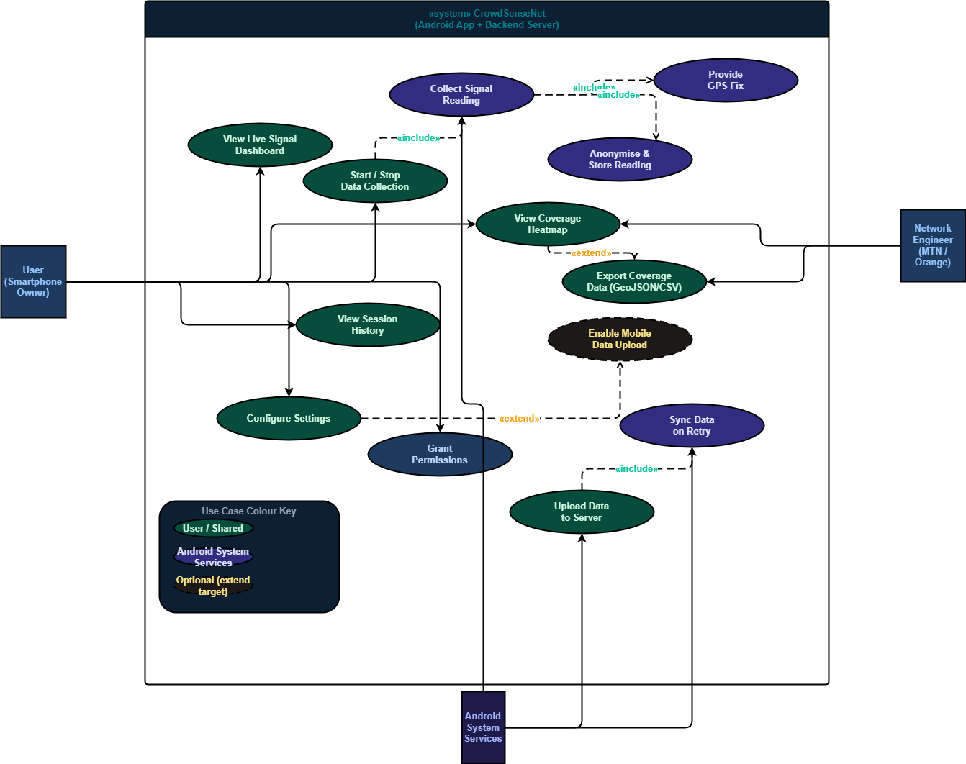
Figure 4: Use Case Diagram for CrowdSenseNet

6.0 Sequence Diagram
Prepared by: Bessong Takang Tabot Willy

6.1 What is a Sequence Diagram?
A sequence diagram is a behavioural UML diagram that models the time-ordered flow of messages between the actors and components of a system for a specific scenario. Unlike the use case diagram, which shows what the system does, the sequence diagram shows exactly how it happens, step by step, in the right order.

6.2 Actors and Lifelines
Six lifelines are defined for the core data collection scenario. Each represents a distinct actor or system component that participates in the interaction.
Lifeline | Type | Role in the Scenario
User | Human actor | The smartphone owner who opens the app, grants consent, starts and stops collection, and receives feedback
Mobile App | System component | The CrowdSenseNet Android application. Acts as the central coordinator throughout the session
Telephony API | System component | The Android TelephonyManager. Supplies RSRP, SINR, RSRQ, and RSSI values on request
GPS Module | System component | The Android FusedLocationProvider. Returns latitude, longitude, and fix accuracy
Backend Server | System component | The FastAPI cloud REST API. Receives, validates, and stores uploaded measurements
Database | System component | The PostgreSQL/PostGIS store on the backend. Persists all readings and serves heatmap queries

Table 6.1: Lifelines in the sequence diagram

6.3 Message Flow

6.3.1 Phase 1: App Launch and Consent
The user opens the application. The Mobile App displays a consent screen and requests location and phone state permissions from Android. Once the user grants permissions, the app confirms consent and activates the background sensor loop.

6.3.2 Phase 2: Data Collection Loop
This phase is modelled as a loop combined fragment that repeats every 10 seconds while the device is moving.
- The Mobile App sends a read request to the Telephony API.
- The Telephony API returns RSRP, SINR, and RSRQ values.
- The Mobile App simultaneously requests a GPS fix from the GPS Module.
- The GPS Module returns latitude, longitude, and an accuracy estimate.
- The Mobile App evaluates the accuracy value. Any fix worse than 15 metres is discarded silently without interrupting the loop.
- Valid readings are anonymised on-device: all device-identifiable fields are removed and the session UUID is assigned.
- The anonymised GeoJSON record is written to the local Room database.
- The Home screen updates to show the latest signal values to the user.
At any point during the loop, the user may send a toggle command to pause or resume collection. The Mobile App updates its state immediately.

If the device is stationary for more than 30 seconds, the app pauses the collection loop automatically and resumes when movement is detected (speed above 5 km/h). This is the primary mechanism for meeting the battery efficiency requirement.

6.3.3 Phase 3: Upload
The upload phase is modelled as an alt combined fragment with two branches.
WiFi available branch: the WorkManager service detects a WiFi connection and dispatches the buffered GeoJSON batch to the Backend Server over HTTPS/TLS 1.2. The backend validates and cleans the data, writes each record to the Database, receives an OK confirmation, and returns an upload acknowledgement to the Mobile App. The app notifies the user that the upload was successful and marks the readings as synced in the local database.

No WiFi / WiFi-only restriction active branch: the app queues the data locally and notifies the user that the upload has been deferred. The WorkManager schedules a retry in 30 minutes.

6.3.4 Phase 4: Coverage Map Serving
When the Map screen is opened, the Mobile App queries the Backend Server for the latest coverage data. The Backend Server requests the relevant coverage data from the Database, which returns a GeoJSON export. The backend renders the heatmap and returns it to the Mobile App for display. When a network engineer queries the system through the web interface, the same flow applies.

6.4 Design Decisions
Decision | Rationale / Evidence
10-second collection interval while moving, pause when stationary | Balances the conflict identified in Task 3 between real-time data collection and battery efficiency. Engineers confirmed 5 seconds as the minimum; 10 seconds during movement with pausing when stationary keeps battery drain below 5% per hour.
GPS accuracy filtering at 15 metres, applied before storage | Threshold set by network engineer interviews. Applied on-device before the record is written to avoid corrupting the coverage map with inaccurate coordinates.
WiFi-only upload as default, mobile data as opt-in toggle | 56% of survey users required data-saving conditions. Modelled as an alt fragment to make both execution paths explicitly testable.
Data anonymisation performed on-device before any record leaves local storage | Non-negotiable requirement for 56 of 100 survey respondents. Removing PII on the device means the backend never receives identifiable data, not even in transit.
Activation bars on Mobile App for full session duration | Reflects the app's role as the persistent central coordinator. Backend and database lifelines activate only during upload and query phases, correctly showing their idle periods.
Random UUID generated on first launch, stored in encrypted SharedPreferences | Resolves the conflict between full anonymity and device-consistent readings for the ML model (Task 3, Section 2.1.3).

Table 6.2: Sequence diagram design decisions and evidence

6.5 Sequence Diagram Illustration
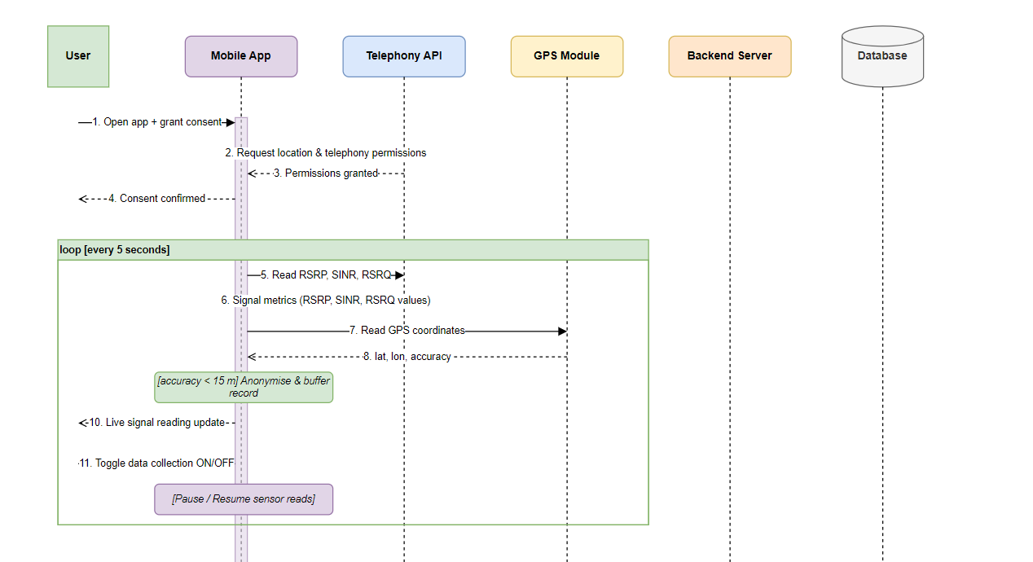
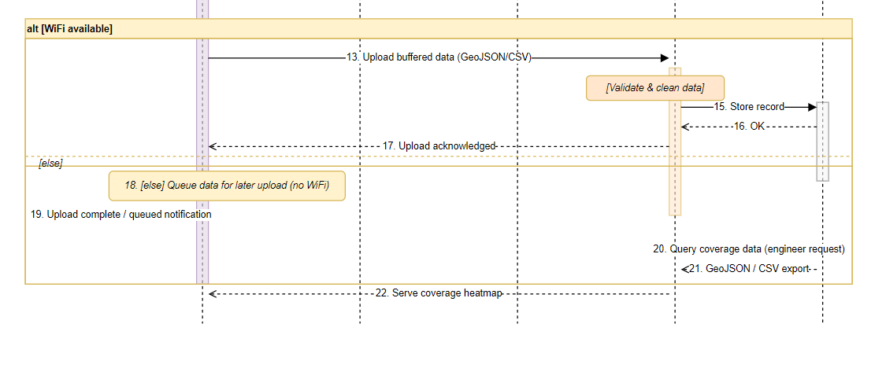
Figure 5: Sequence Diagram for the Core Data Collection Scenario

7.0 Class Diagram
Prepared by: Ayuk Amelia Agbor Orock

7.1 What is a Class Diagram?
A class diagram is a structural UML diagram that describes the static structure of a system. It shows the classes (the building blocks of the code), the attributes each class holds, the operations each class can perform, and the relationships between classes. It is produced before any code is written so that the development team has a shared blueprint for the architecture.

7.2 Architectural Overview
CrowdSenseNet follows the MVVM (Model-View-ViewModel) architectural pattern, which is the standard recommended architecture for Android applications built with Kotlin. MVVM separates the application into three concerns: what the user sees (the View), the data and business logic (the Model), and the layer that connects them (the ViewModel). This separation makes the codebase easier to test, maintain, and extend.

The full system is divided into seven packages, each with a single clear responsibility.
Package | Responsibility | Contents
Presentation Layer | Screens the user sees and interacts with | 5 screen classes
ViewModel Layer | Holds live data and connects screens to business logic | 4 ViewModel classes
Domain / Service Layer | Core workers: signal reading, syncing, permissions | 4 classes + 2 interfaces
Repository Layer | Bridge between ViewModels and data sources | 3 Repository classes
Data Layer | Data objects stored in the local database | 5 entity classes
Network Layer | All communication with the backend server | 3 network classes
Enumerations | Fixed value sets used across the system | 3 enumerations

Table 7.1: CrowdSenseNet package structure

7.3 Classes by Layer

7.3.1 Presentation Layer
These classes handle only what the user sees. No business logic or database calls appear here. Each screen class observes its corresponding ViewModel and updates automatically when data changes.
Class | Purpose
OnboardingScreen | Shown once on first launch. Walks the user through what the app does, what data it collects, and requests the required Android permissions.
HomeScreen | The main screen. Shows live signal metrics (RSRP, RSRQ, SINR, RSSI), GPS status, current session status, and a start/stop button.
MapScreen | Displays the real-time coverage heatmap. Colour-coded zones show good, average, poor, and insufficient data areas. Users can tap any zone to see details.
HistoryScreen | Shows a list of all past data collection sessions with their date, duration, number of readings, and upload status.
SettingsScreen | Allows the user to configure collection mode, enable or disable mobile data upload, change language, and delete all locally stored data.

Table 7.2: Presentation layer classes

7.3.2 ViewModel Layer
ViewModels sit between the screens and the data. They hold LiveData objects that the screens observe and automatically update when values change. The screen never fetches data directly; it watches the ViewModel and reacts to changes.
Class | Purpose
HomeViewModel | Provides the HomeScreen with live values for RSRP, RSRQ, SINR, RSSI, session status, and total readings.
MapViewModel | Fetches ML predictions from the PredictionRepository and provides them to the MapScreen for heatmap display.
HistoryViewModel | Retrieves all past sessions from the SessionRepository and provides them as a live list.
SettingsViewModel | Loads and saves user preferences through the User entity. Handles the delete-all-data action.

Table 7.3: ViewModel layer classes

7.3.3 Domain / Service Layer
This layer contains the core workers of the application. These classes run the actual business logic: reading signal data, managing GPS, checking permissions, and uploading data.
Class / Interface | Type | Purpose
DataCollector | Interface | Defines the contract for any data-collecting class. Any implementation must provide startCollection(), stopCollection(), pauseCollection(), and resumeCollection() methods.
DataUploader | Interface | Defines the contract for any data-uploading class. Requires uploadData(), checkConnectivity(), and scheduleRetry() methods.
SignalCollector | Class | Implements DataCollector. Reads RSRP, RSRQ, SINR, RSSI, and Cell ID via TelephonyManager every 10 seconds while moving. Creates SignalReading objects and saves them to the local database.
SyncManager | Class | Implements DataUploader. Monitors WiFi connectivity and uploads queued readings to the backend. Retries automatically every 30 minutes if upload fails.
PermissionManager | Class | Handles Android permission requests for location access, phone state, and battery optimisation exemption.
LocationManager | Class | Manages GPS updates via FusedLocationProvider. Detects GPS disabled state and notifies the app to pause collection.

Table 7.4: Domain / Service layer classes and interfaces

7.3.4 Repository Layer
Repository classes act as the single source of truth for data. The ViewModel asks the Repository for data, and the Repository decides whether to retrieve it from the local database or the backend. The ViewModel never knows where the data comes from.
Class | Purpose
SignalRepository | Saves signal readings to the local database, retrieves unsynced readings for upload, and marks readings as synced after successful upload.
SessionRepository | Creates new sessions, ends sessions, retrieves all past sessions, and deletes sessions from the local database.
PredictionRepository | Fetches ML coverage predictions from the backend through the BackendAPI and provides them to the MapViewModel.

Table 7.5: Repository layer classes

7.3.5 Data Layer
These are the data entities, the actual objects stored in the local Room database and passed between layers. Each entity maps directly to a table in the SQLite database.
Class | Key Attributes | Purpose
SignalReading | id, deviceUUID, rsrp, rsrq, sinr, rssi, cellId, latitude, longitude, timestamp, networkType, isSynced, sessionId | One complete signal measurement. Every reading includes both signal parameters and GPS coordinates.
Session | sessionId, deviceUUID, startTime, endTime, totalReadings, uploadStatus, isActive | One data collection session from start tap to stop tap.
User | deviceUUID, language, collectionMode, wifiOnlyUpload, intervalSeconds, hasCompletedOnboarding | Stores the anonymous device token and all user preferences. No personal information.
MLPrediction | predictionId, latitude, longitude, predictedRsrp, coverageClass, confidenceScore, predictionDate | One coverage prediction for a specific geographic location.
LocalDatabase | dbInstance, storageUsedMB, maxStorageMB | The Room database instance. Manages all local storage with a 50MB cap.

Table 7.6: Data layer entity classes

7.3.6 Network Layer
This layer handles all communication between the Android app and the remote backend. All transmissions use HTTPS/TLS 1.2.
Class | Purpose
BackendAPI | Sends uploaded signal readings to the backend and fetches ML predictions. Handles authentication tokens and error responses.
APIResponse | Represents the server response after each API call. Contains the status code, success flag, message, and any returned data.
APIError | Represents an error from the backend. Distinguishes network errors from server errors and determines whether the call should be retried.

Table 7.7: Network layer classes

7.3.7 Enumerations
Enumeration | Values | Used In
CoverageClass | GOOD, AVERAGE, POOR, HOLE, INSUFFICIENT_DATA | MLPrediction: classifies predicted signal quality
NetworkType | LTE, NR_NSA, NR_SA, UMTS, EDGE, UNKNOWN | SignalReading: records the network generation at the time of measurement
CollectionMode | BACKGROUND, FOREGROUND_ONLY, PAUSED | User: stores whether the app collects data always, only when open, or not at all

Table 7.8: Enumerations used in the class diagram

7.4 Relationships

7.4.1 Relationship Types Used
The class diagram uses five relationship types: Dependency (dashed arrow, one class temporarily uses another), Association (solid arrow, one class holds a reference to another), Aggregation (hollow diamond, one class contains another but the child can exist independently), Composition (filled diamond, the child cannot exist without the parent), and Realisation (dashed arrow with hollow head, a class implements an interface).

7.4.2 Dependency Relationships (1 to 1)
From | To | Label
HomeScreen | HomeViewModel | observes
MapScreen | MapViewModel | observes
HistoryScreen | HistoryViewModel | observes
SettingsScreen | SettingsViewModel | observes
OnboardingScreen | PermissionManager | requests
HomeScreen | SignalCollector | controls
SignalCollector | PermissionManager | requires
SyncManager | PermissionManager | checks
BackendAPI | APIResponse | returns
BackendAPI | APIError | handles
User | CollectionMode | uses enum
MLPrediction | CoverageClass | uses enum
SignalReading | NetworkType | uses enum

Table 7.9: Dependency relationships

7.4.3 Association Relationships
From | To | Cardinality | Label
HomeViewModel | SignalRepository | 1 to 1 | uses
HomeViewModel | SessionRepository | 1 to 1 | uses
MapViewModel | PredictionRepository | 1 to 1 | uses
HistoryViewModel | SessionRepository | 1 to 1 | uses
SettingsViewModel | User | 1 to 1 | manages
SignalRepository | LocalDatabase | 1 to 1 | queries
SessionRepository | LocalDatabase | 1 to 1 | queries
PredictionRepository | BackendAPI | 1 to 1 | fetches from
SignalCollector | LocationManager | 1 to 1 | uses
SyncManager | SignalRepository | 1 to 1 | reads from
SyncManager | BackendAPI | 1 to 1 | calls
User | Session | 1 to 0..* | starts
BackendAPI | MLPrediction | 1 to 1..* | triggers

Table 7.10: Association relationships

7.4.4 Composition and Aggregation Relationships
Type | From | To | Cardinality | Meaning
Composition | Session | SignalReading | 1 to 1..* | A session owns its readings. If a session is deleted, all its readings are deleted too.
Composition | SignalCollector | SignalReading | 1 to 1..* | The signal collector creates and owns readings during active collection.
Aggregation | LocalDatabase | SignalReading | 1 to 0..* | The database stores readings but a reading can exist in memory before it is committed.
Aggregation | LocalDatabase | Session | 1 to 0..* | The database stores sessions but a session object exists in memory before storage.

Table 7.11: Composition and aggregation relationships

7.5 Class Diagram Illustration
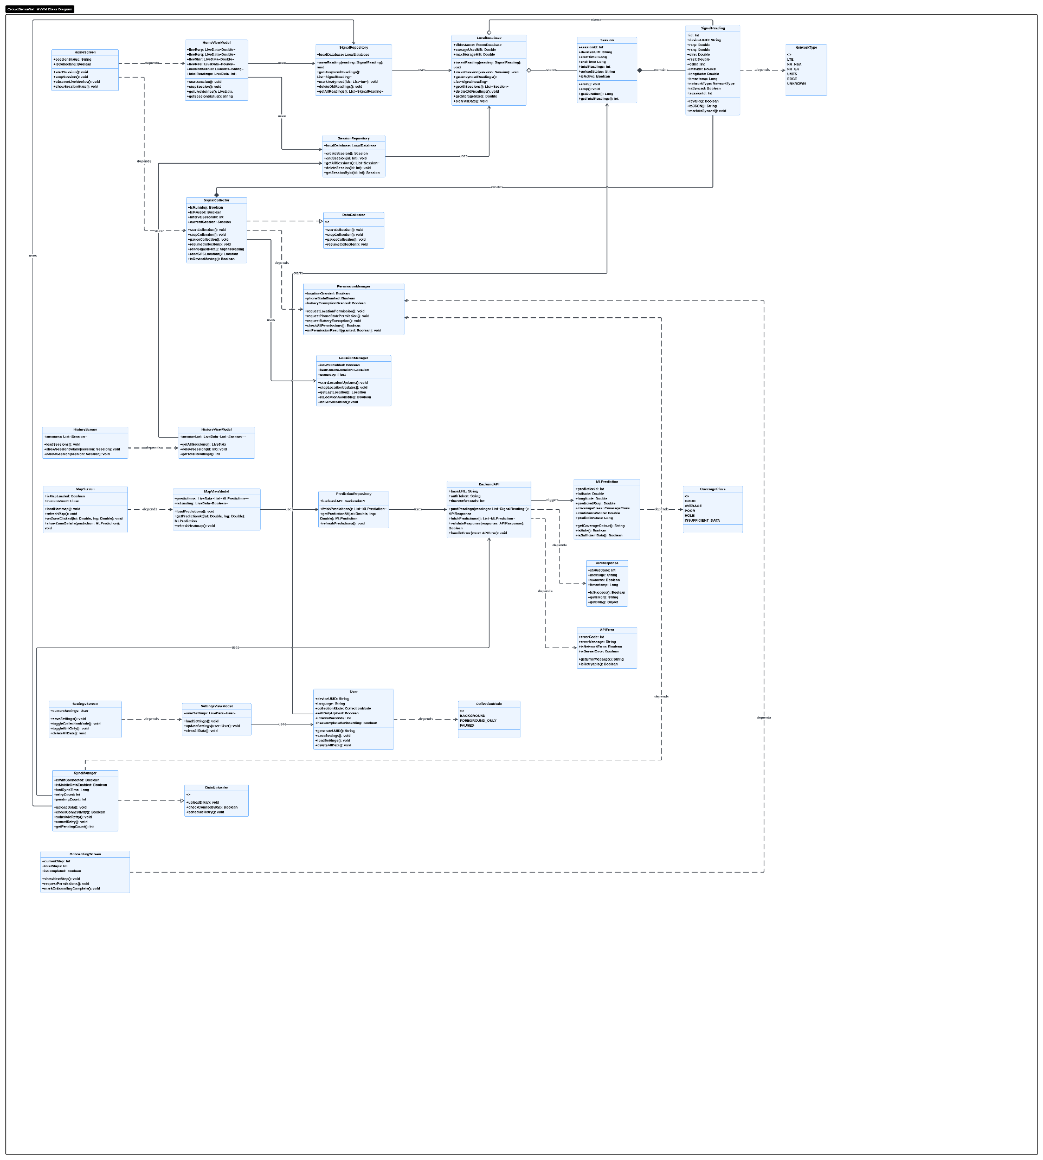
Figure 6: Class Diagram for CrowdSenseNet (MVVM Architecture)

8.0 Deployment Diagram
Prepared by: Ngome Fernandez Manyaka

8.1 What is a Deployment Diagram?
A deployment diagram is a structural UML diagram that shows how software components are distributed across physical hardware. Where the class diagram shows what the code looks like, the deployment diagram shows where the code runs. It maps software artifacts, components, and their dependencies onto the physical or virtual execution environments that host them.

8.2 Architecture Overview
CrowdSenseNet follows a three-tier architecture as defined in the Task 3 SRS. The deployment diagram identifies five distinct execution environments across these three tiers.
Tier | Node | Role
1 (Client) | Android Device | Signal collection, local storage, user interface, background sync
1 (Client) | Android System Services | OS-level hardware APIs consumed by the app (TelephonyManager, FusedLocationProvider)
2 (Backend) | Backend Server | Data ingestion, validation, spatial storage, REST API, GeoJSON and CSV export
3 (Analytics) | ML Analytics Server | Coverage prediction, heatmap generation, model retraining (future phase)
External | Google Maps Tile Service | Third-party mapping tiles for the heatmap display layer

Table 8.1: Deployment nodes and their roles

8.3 Node Breakdown

8.3.1 Android Device
This node is the most complex in the diagram. It hosts the application code and all local data stores.
Components:
- Kotlin UI Application: the four-screen user interface (Home, Map, History, Settings) built with Material Design 3.
- WorkManager Service: the background sync agent that schedules uploads, enforces the WiFi-only constraint, and retries failed uploads every 30 minutes.
- Adaptive Sampling Controller: logic that monitors device speed and pauses collection when stationary for more than 30 seconds, resuming when speed exceeds 5 km/h. This is the primary mechanism for the battery efficiency requirement.
- UUID Generator: runs once on first launch to produce the anonymous device token attached to every reading.

Artifacts:
- crowdsensenet.apk: the installed Android application package.
- Room Database (SQLite): local offline data store with a 50MB storage cap.
- uuid.prefs: encrypted SharedPreferences file holding the anonymous UUID and the bearer authentication token.
- settings.prefs: user preference store for upload mode, sampling interval, and collection mode.

8.3.2 Android System Services
This node represents the Android OS hardware access layer. It is shown separately because CrowdSenseNet consumes these APIs at a defined interface boundary rather than owning them.
- TelephonyManager: exposes RSRP, RSRQ, SINR, RSSI, Cell ID, and network operator data from the cellular modem hardware.
- FusedLocationProvider: blends GPS, WiFi positioning, and cell tower triangulation to produce location fixes with an associated accuracy estimate. Readings with accuracy worse than 15 metres are discarded by the Kotlin app immediately after the fix is received.

8.3.3 Backend Server
The backend server runs Python FastAPI and PostgreSQL with the PostGIS spatial extension.
- FastAPI REST API: the sole entry point to the backend. Handles authentication, request routing, and the GeoJSON and CSV export endpoints used by network engineers.
- Data Validator: enforces the Cameroon bounding box filter, the duplicate GPS averaging rule (within 10 metres), and the authentication token check on every incoming batch.
- PostGIS Query Engine: executes spatial queries for heatmap grid generation, proximity clustering, and bounding box filtering directly within the PostgreSQL engine.

8.3.4 ML Analytics Server (Future Phase)
This node hosts the machine learning pipeline. It is included in the diagram because the data pipeline in Tiers 1 and 2 is being built specifically to feed it, even though it is a Won't Have (now) requirement from the Task 3 MoSCoW prioritisation.
- Coverage Prediction Model: classifies geographic grid cells as good, average, or coverage hole. Requires at least 50 readings per 1 km squared and must achieve at least 80% classification accuracy.
- Model Training Pipeline: periodically pulls fresh batches from PostgreSQL and retrains the model as more data accumulates.
- Heatmap Generator: converts prediction outputs into GeoJSON feature collections returned to the backend.

8.4 Inter-Node Communication Paths
From | To | Protocol | Description
Android Device | Backend Server | HTTPS / TLS 1.2+ | WorkManager uploads validated reading batches as JSON. WiFi by default, mobile data opt-in. 30-minute retry on failure.
Backend Server | Android Device | HTTPS / TLS 1.2+ | FastAPI returns the cached heatmap GeoJSON when the app Map screen requests it.
Backend Server | ML Analytics Server | Internal / batch | Scheduled bulk export of validated readings from PostgreSQL as a training data snapshot.
ML Analytics Server | Backend Server | Internal / API | Prediction GeoJSON returned after each prediction run. Backend caches it and serves it on the second path above.
Backend Server | Google Maps | HTTPS | Map tile requests for the base layer rendered under the coverage heatmap.

Table 8.2: Inter-node communication paths

8.5 Modelling Tool and Challenges
The deployment diagram was built using EdrawMax. An initial attempt in Modelio was abandoned after two technical blockers: artifacts could not be placed inside node boundaries using drag-and-drop, and the Component creation tool was absent from the default deployment diagram palette. EdrawMax resolved both issues and produced a clean, correctly structured diagram.

8.6 Deployment Diagram Illustration
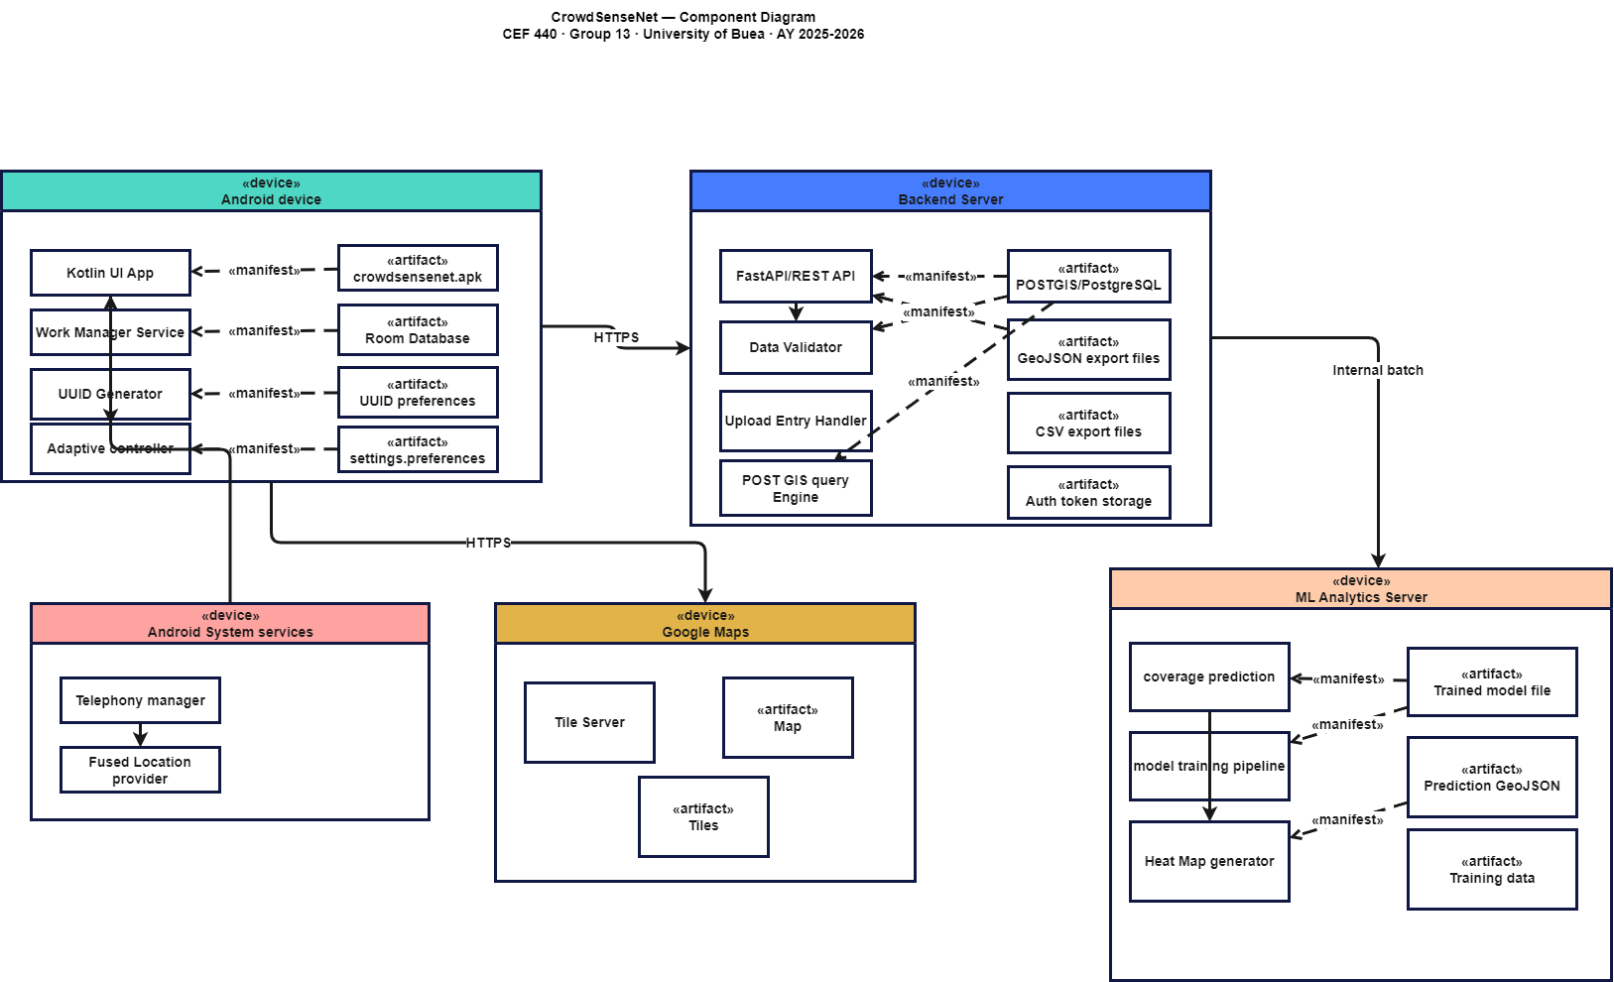
Figure 7: Deployment Diagram for CrowdSenseNet

9.0 Member Contributions
This section provides an honest account of each team member's contribution to Task 4. All five members participated in the shared tasks of reviewing the Task 3 SRS before starting, attending planning discussions, and cross-checking each other's diagrams for consistency. The individual contributions below reflect the primary ownership of each section.

Name | Student ID | Section Owned | Contribution Description | Estimated Participation
Tadjeu Ngnintedem Aubry-Junex | FE23A148 | Context Diagram (Section 3) | Led the design and documentation of the context diagram. Identified all external actors, defined data flows, and wrote the full explanatory report. Validated the diagram against the Task 3 stakeholder list. | 20%
Imele Azafa Jose de Kajos | FE23A068 | Data Flow Diagram and Use Case Diagram (Sections 4 and 5) | Designed and documented both the Level 1 DFD and the Use Case Diagram. Defined all internal processes, data stores, actors, use cases, and relationships. These two diagrams required the most structural analysis work. | 25%
Bessong Takang Tabot Willy | FE23A025 | Sequence Diagram (Section 6) | Produced the sequence diagram for the core data collection scenario. Identified all lifelines, mapped the message flow across all four phases, documented design decisions with evidence from Task 2 data, and justified the combined fragments. | 15%
Ayuk Amelia Agbor Orock | FE23A020 | Class Diagram (Section 7) | Produced the complete class diagram covering all 29 classes, 2 interfaces, 3 enumerations, 7 packages, and 32 relationships following the MVVM pattern. Documented all attributes, operations, and relationship cardinalities. | 25%
Ngome Fernandez Manyaka | FE23A111 | Deployment Diagram (Section 8) | Designed and documented the deployment diagram across all five nodes. Identified components, artifacts, and communication paths. Led the EdrawMax modelling and documented the tool challenges encountered with Modelio. | 20%

Table 9.1: Member contribution summary

Note on participation percentages: the slight variation between members reflects the difference in scope between sections. The Data Flow and Use Case Diagram section (Section 4 and 5) and the Class Diagram section (Section 7) involved the most analysis and documentation work, which accounts for their higher weighting. All members reviewed and approved each other's sections before submission.

10.0 Conclusion
This report has produced a complete system modelling and design for CrowdSenseNet, covering all six UML diagram types required by Task 4. Each diagram addresses a different layer of the system's design, and together they provide a full architectural blueprint ready for the implementation phase.

The context diagram established the system boundary and confirmed that all four stakeholder groups (users, network engineers, regulators, and academic supervisors) are properly accounted for. The data flow diagram opened the system boundary and mapped the seven internal processes through which raw signal readings become processed coverage maps. The use case diagram captured twelve functional interactions between the three primary actors and the system, including include and extend relationships that show the dependencies between features.

The sequence diagram modelled the runtime behaviour of the core data collection scenario across four phases, with explicit design decisions grounded in Task 2 evidence: the 10-second adaptive sampling interval, the 15-metre GPS accuracy filter, the on-device anonymisation step, and the WiFi-only upload default. The class diagram described the complete static structure of the Android application following the MVVM pattern, covering 29 classes, 2 interfaces, 3 enumerations, and 32 relationships across 7 packages. The deployment diagram mapped all software components onto five physical or virtual nodes across the three-tier architecture.

Every design decision in this report is traceable to a specific requirement in the Task 3 SRS and, behind that, to real stakeholder evidence from Task 2. The team is confident that this design correctly represents the system that needs to be built and provides a solid, evidence-based foundation for the implementation phase that follows.

